PAPER HEADING IN ENGLISH LANGUAGE: TIMES NEW ROMAN 16 CAPITAL LETTERS CENTRE
Name SURNAME FIRST AUTHOR – Name SURNAME SECOND AUTHOR– Name SURNAME NEXT AUTHOR
Abstract: A summary of the main ideas in the presented paper in English, max. 150 words. Font Times New Roman, 12, Align the Edges. Page size A4 (21 cm x 29, 7 cm) size 2.5 cm from the top edge, bottom 2.5 cm, left 2.5 cm, right 2.5 cm. The style should be concise, factual and clear. Abstract contains a brief definition of the main objectives of the work, describes the methods used, and summarizes the results and work conclusions and the way using them in a practice.
Keywords: Key words in English language, max. 5 words. Font Times New Roman, 12, Align the edges - Justify.

Introduction
The recommended language for writing the post is English, so all its points should be in this language.

Article Structure
Subheadings in the article are written in font type Times New Roman, 12, Bold, Align Left, without numbering.
Introduction and the article body are written in font type Times New Roman, 12, Justify, without paragraphs created by Indents and Spacing Tab. Single Spacing applies on the whole document.
New information should be expressed in a new line.
Do not number the pages.
Bullets or numbers indicate either entered as the Order Number or Sign, Align Left, Indent 0.5 cm, line start with a Capital Letter, as example:
• Text,
• Text.
Pictures, charts, graphs, diagrams put it in the text so that omit one row prior the figure and one row under the description of the image; Center the image position. Description of the figure make Font type Times New Roman, 10, Bold, Centered, without a row space under the image. Indication in the text and the subsequent sequential numbering and description of figures name as Fig. 1 Description of figure, Fig. 2 Description of figure, etc.
Don’t forget to mention the details presented in the Picture as the part of the text in the article.

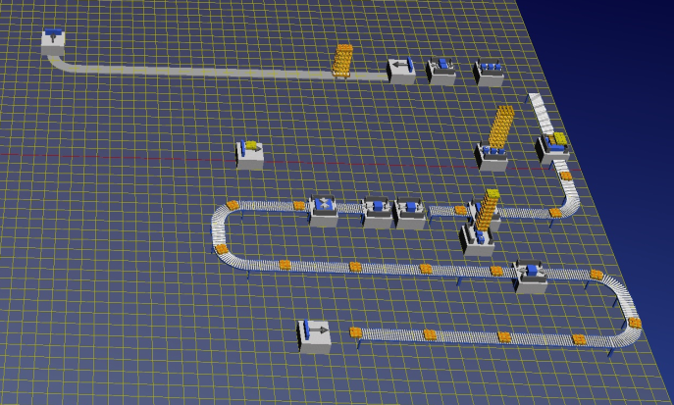
Fig. 1 2D Simulation model of bottle filling line

Tables insert in the text similarly as the way of inserting the Picture, except the number and name of the table is situated above the placement of the table. Font type inside the table is equal to Font Type of the table name – Times New Roman, 10, Justify. Make one row empty space above the table name and one row empty space under the end of the table. Use Single Spacing.

Tab. 1 Technologies as initiative to a change
Former state | Technology = impulse of a change | New state
The information is present at one time in one place. | Shared databases. | The information is present at one time, in those places where it is needed.
Complex work can only be done by expert. | Expert systems. | Versatile worker is able to replace expert.
It is necessary to choose between centralization and decentralization. | Telecommunication tools, networks. | It is possible to use the current benefits of centralization and decentralization.

Conclusion
Sum up the target of the contribution – methods used and proposed, goals and outcomes reached, assumptions made, etc.
Contributions should be sent in MS Word ".doc", in case the formal corrective interventions by editors would be required. Recommended range of contributions is 3-6 pages in the template. Contributions may be published in English. Please, follow the standards according to ISO 690 and ISO 690-2 or APA style.
Review process: peer reviewed process by two reviewers.

Notice: A Recommended Structure
Quite common and recommended, but not suitable for ALL articles by rule, is the following structure. Please try if it is possible to follow it:
• Introduction.
• Literature review (sometimes with introduction).
• Methods and methodology.
• Results and Discussion.
• Conclusion.
• Acknowledgements (if any).
• References.

References
[1] AMSTRONG, M.: How to Become a Better Manager. Victoria Publishing, Praha 1995, ISBN 88-88828-15-5.
[2] SLOTA, J., et al.: The Sensitivity of a Photogrammetric Method in Formability Analysis. In: Acta Mechanica et Automatica. Vol. 7, No. 2 (2013), ISSN 1898-4088, pp. 117-123.
[3] SjF TU Kosice, KVTaR. The Manual for programming the KUKA robots, [CD-ROM]. Kosice: KVTaR, pp. 1-99.
[4] STOFKOVA, K.: Networking Business. In: Management and networking business in Knowledge Economics. Zilina: University of Zilina, 2013, ISBN 978-80-554-0804-0, pp. 25-60.
Contact address
Ing. Jozef Trojan, PhD.
Technical University of Kosice, Faculty of Mechanical Engineering, Department Industrial and Digital Engineering, Park Komenskeho 9, 042 00, Kosice, Slovakia
e-mail: jozef.trojan@tuke.sk
(Font type Times New Roman, 12, Justify)

